Story-to-MR Automation — Approach
Oct 28, 2026 · @Pratik

1. Summary
Story-to-MR Automation turns a story into a reviewed merge request with no clicks. When a developer moves an IKG, NLG or ODM story to In progress in the current iteration, the tool picks it up, generates the code and opens an MR to the target branch (for IKG, ikg-dev). It then labels the story ai_coding_done.
It reuses almost everything from Agile Dev Assist: the agents (story, knowledge, data, repo, planner, coder, validator, reviewer), the context packs, and the git branch, commit, push and MR code. Three things are new:
- A watcher that checks GitLab every few minutes and spots stories that have just moved to In progress.
- A worker that runs the existing pipeline for that story without anyone clicking, then pushes and raises the MR.
- An onboarding page where any system (IKG, NLG, ODM or a new one) is set up once, with no code changes.
The hardest part is not the AI. It is getting approval for the tool to push and raise MRs in the developer's name without the developer typing a token. Section 4 sets out the options. It recommends one-time developer consent through GitLab, with a bot account as the fallback.
Nothing is ever merged automatically. A person still reviews and merges every MR.

2. End-to-end flow
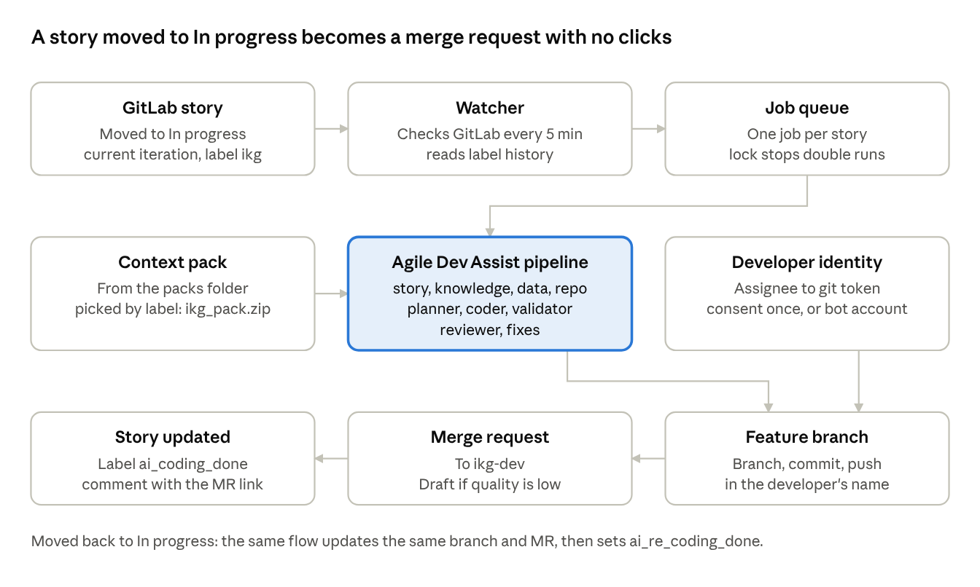
P7 end-to-end flow · 9 steps
The watcher and queue decide what runs. The pipeline (highlighted) is the existing Agile Dev Assist engine, and the developer identity decides whose name the push carries.

3. How stories are picked up
A plain rule picks stories, not an AI agent: iteration is current, the label matches a system, and the story has just moved to In progress. That keeps pick-up cheap, predictable and easy to audit. The AI agents start only after a story is picked.

Checking GitLab: three options
Option | How it works | Pros | Cons
Regular check (polling) — start here | Every 3–5 minutes, ask GitLab for issues in the current iteration with the system labels, changed since the last check | Outbound calls only, so easy to approve; simple | Picks a story up within minutes, not instantly
Webhook | GitLab calls an automation URL when an issue changes, signed with a shared secret | Instant; no wasted calls | Needs a firewall opening from GitLab to the host; an event is lost if the automation is down
Both — target | Webhook for speed, plus a check every 15 minutes to catch misses | Most reliable | Two code paths
GitLab's issues API can filter by label, by current iteration and by "updated after", so each check only returns stories that changed.

Spotting "moved to In progress"
A list of issues shows only the current state, not the moves. So for each changed story the watcher reads its label history (the resource_label_events API). That history says when In progress was added and when the automation's own labels were added. A small state table remembers each story: last status seen, last run, branch, MR and run count. The table stops the same move from being processed twice.
Situation | Rule | Result
First run | In progress added; story never processed | Full pipeline, new branch, new MR, label ai_coding_done
Re-run | In progress added after the last ai_coding_done or ai_re_coding_done | Update the same branch and MR, label ai_re_coding_done
The automation's own change | Label event made by the automation's account | Ignored, so it never triggers itself
Moved in and straight out again | In progress removed before the run starts | Job cancelled
No assignee, or assignee not onboarded | Any trigger | No run; label ai_blocked and a comment saying why
Pack missing or too old | Any trigger | No run; label ai_blocked and a comment
The GitLab admin must confirm how In progress is recorded. It could be a scoped label (workflow::In progress), a board column backed by a label, or GitLab's newer Status field. The onboarding page asks which one, because each is read differently.

4. Acting in the developer's name
Recommendation: one-time developer consent through GitLab (option A), with a bot account (option B) as the fallback. The story's assignees field already holds the developer's GitLab user record (id, username, email), so finding the person is easy. The real question is how the automation gets the right to push and raise MRs as that person.
Option | How it works | Who shows as author | For | Against
A. One-time consent (GitLab OAuth) — recommended | Each developer clicks "Authorize" once on the onboarding page. GitLab gives the automation a refresh token for that user, kept in the vault under their GPN. Before each run the automation swaps it for a short-lived access token. | The developer: commits, push and MR | Genuine delegation; the developer can withdraw it in GitLab settings; no tokens typed or chased | GitLab admin must register an OAuth app; needs security sign-off
B. Bot account plus named owner — fallback | A dedicated GitLab service account pushes and opens the MR. The MR is assigned to the developer, commits carry Co-authored-by: <developer>, and the MR text says who it was made for. | The bot (MR author); the developer is assignee and co-author | Easiest to approve; one token to manage | The manager must accept the bot as MR author
C. Developer-stored personal token | Developers paste a personal access token on a self-service page. The automation checks the token belongs to that GPN and stores it in the vault at git/<gpn>. | The developer | Works without admin help | Many long-lived tokens; they expire (at most a year) and need renewing
D. Admin impersonation tokens — avoid | An admin token creates short-lived tokens for any user. | The developer | No per-user setup | An admin key that can act as anyone; security will almost certainly refuse
Rules that apply whichever option is chosen:
- The commit author field is never set to the developer's name using someone else's token. That is impersonation, and GitLab push rules often reject it.
- No assignee, more than one assignee, or an assignee who hasn't onboarded: no run, label ai_blocked and a comment on the story.
- Tokens and refresh tokens live only in the vault, are used per command and are masked in logs, as in Agile Dev Assist today.
- This replaces Agile Dev Assist's current rule that a push always needs the user's token typed in the form. That change needs written sign-off from security.
GPN-to-user mapping: the assignee's GitLab username or email is matched to the GPN through the directory (or a mapping table kept on the onboarding page). The vault path is then derived from the GPN.

5. Running the pipeline with no clicks
The worker calls the same Agile Dev Assist engine a user drives from the web page, filling the inputs from the story and the system's settings.
Input | Where it comes from
Story | Issue title, description and acceptance criteria
Context pack | Packs folder, chosen by label through the system's file pattern (ikg → ikg_pack.zip)
Repository, base and target branch | System settings (ikg repo, ikg-master, ikg-dev)
Branch name | System template, e.g. <story id>-ikg-<feature>-ai-code-agent
Who pushes | The assignee, through the identity option chosen in section 4
The steps are unchanged: story → knowledge → data → repo → planner → coder → validator → reviewer, with fixes when the validator or reviewer finds problems. Branch, commit, push and MR use the existing git code, including safe pushes when someone else has pushed to the same branch.

Quality gate
- A good review and confidence above the threshold → a normal MR.
- A failed review or low confidence → the code is still pushed, but the MR opens as Draft with the review findings in its description. A comment on the story asks the developer to look.
- A pipeline error → no push; label ai_failed and a comment with the reason.
- Nothing is ever merged automatically.

Re-runs (story moved back to In progress)
- Reuse the same feature branch and update the existing MR; never open a second one.
- Read what changed since the last run: new story comments, unresolved MR discussions, and edits to the story description.
- If the description changed, make a fresh plan. If only comments were added, apply them as a change request to the existing code.
- Push new commits and set ai_re_coding_done.
- Stop after a set number of re-runs per story (for example 5) and ask for a person.

Developers can take over
Each automatic run is saved as a chat in the Agile Dev Assist web app, owned by the assignee. If the result is mostly right, the developer opens that chat and finishes the work by hand from where the automation stopped.

6. Architecture and technology
The automation runs on the Agile Dev Assist host as a headless worker beside the web app. That way it shares the packs folder (filled by the Knowledge Pack job over SFTP), the git mirrors, the cache and the header-based sign-in. Everything is Python, reusing Agile Dev Assist code.
Component | What it does | Technology
Onboarding page | Set up systems, developers' consent, test buttons, run history | New pages in the existing Agile Dev Assist web app, same sign-in
Settings store | System settings, developer mapping, story state, run history | Greenplum tables in a dedicated schema, written through a separate writer login. The agents' own data queries stay on the read-only login
Watcher | Checks GitLab on a timer; later also receives webhooks | Python timer loop (APScheduler) plus a webhook route
Job queue | One job per story; a lock stops two runs on the same story | Greenplum table used as a queue (tens of rows a day)
Worker | Runs the pipeline, pushes, raises or updates the MR, sets labels and comments | Existing Agile Dev Assist engine, 1–2 workers to control cost and rate limits
Identity service | Turns the assignee into a short-lived git token, or uses the bot | GitLab OAuth refresh tokens in the vault (option A) or the bot token (option B)
Notifier | Comments on the story at start, end and failure; optional email or Teams | GitLab notes API; existing mailer
Why not Airflow? It is possible: a watcher DAG every 5 minutes starting one run per story. But the packs, mirrors and cache would have to be copied to the Airflow workers too. Running beside the web app avoids that and lets developers open the automatic runs as chats.
Why not LangChain or LangGraph? The flow is a fixed sequence that the Agile Dev Assist engine already handles. Adding a framework would add dependencies without adding capability.
Safety switches: a global on/off, on/off per system, a dry-run mode, a daily cap on runs and LLM cost, and a maximum number of re-runs per story.

7. Onboarding page
Each system is one record on this page, so adding NLG, ODM or a new system needs no code change. Secrets are never stored here, only the names of vault variables.
Field | IKG example | Notes
System name | ikg | Must exactly match the story label
Story board / project URL | GitLab group or project URL, plus board id | Where stories live
How In progress is recorded | workflow::In progress label | Label, board column or Status field
Iteration filter | Current | Can be widened later
Git read token (vault variable name) | IKG_GIT_READ_TOKEN | Used by the watcher to read stories
Who pushes | Developer consent (OAuth) | Consent, bot account, or vault personal token
Bot token (vault variable name) | IKG_GIT_BOT_TOKEN | Only if the bot option is chosen
Repository URL | ikg repo URL | Where the code goes
Base branch | ikg-master | Feature branch is created from here
Target branch | ikg-dev | MR goes here
Feature branch template | {story_id}-ikg-{feature}-ai-code-agent | Story id and feature name filled in
Context pack file and maximum age | ikg_pack.zip, 3 days | Older pack → ai_blocked
Labels the automation sets | ai_coding_done, ai_re_coding_done, ai_blocked, ai_failed | Can be renamed
Draft MR threshold | Confidence below 70 | Low quality opens a Draft MR
MR reviewers | Names | Added to every MR
Re-run limit | 5 per story | Then a person is asked
Notify | Email or Teams channel | Besides comments on the story
Check interval | 5 minutes | Polling frequency
Enabled / dry run | On / on | Dry run detects and comments, never pushes
Buttons on the page:
- Test connection for the story board, the repository, the pack and each vault variable.
- Dry run on story # shows what the automation would do for one story without pushing.
- Run history lists each run with its story, developer, branch, MR, result, time and cost.
A second tab handles developers: each one authorises once (option A) and the page shows their GPN, GitLab user and consent status.

Editing settings
Every field above can be changed on the page by an admin of that system. Each save is versioned: who changed what and when, with the option to roll back. A change applies to the next run; a run already going keeps the settings it started with.

Uploading context packs
An admin can upload a pack zip from the page straight into the packs folder, for example to fix a bad pack without waiting for the next Knowledge Pack job.
- Choose the system and the zip (up to 1 GB).
- The page checks it: a valid zip, the pack's own system name matches, required files present. Anything else is rejected with the reason.
- The file is written beside the old one and swapped in at once, so a running job never reads half a file.
- The previous pack is kept as a backup, so Restore previous is one click.
- The upload is recorded: system, file name, size, checksum, who and when.
Re-uploading overrides the current pack. Because the Knowledge Pack job also delivers packs, the page needs a rule for which wins. Suggested: the newest file wins, unless the admin ticks Keep this pack to hold a manual upload until it is unticked.

Where settings are stored (Greenplum)
Table | Holds
auto_system | One row per system: every onboarding field, enabled, dry run
auto_system_history | Each saved version of a system's settings, for audit and rollback
auto_developer | GPN, GitLab user, identity option, consent status (never the token)
auto_pack | Pack versions: system, file, checksum, size, source (job or upload), who, when, kept or not
auto_story_state | Per story: last status seen, branch, MR, run count, last run
auto_job | The queue: story, trigger type, status, worker, start and end times
auto_run | Run history: result, review score, confidence, tokens, cost, MR link
The pack zips stay as files in the packs folder; Greenplum holds only their records. Secrets never go in these tables, only vault variable names. The volume is tiny (tens of rows a day), which Greenplum handles fine. The one weak spot is row locking for the queue, so the worker should claim a job with a single conditional update and check that it won.

8. Preparation steps
These are needed before building starts. Owners are suggestions.
# | Step | Who | Why
1 | Agree the identity option (A consent, B bot, C stored token) in writing | Security, manager | Decides how the automation pushes in a developer's name
2 | Register a GitLab OAuth application (option A) or create a bot account with Developer access to the ikg repo (option B) | GitLab admin | The automation cannot push without one of these
3 | Confirm how In progress is recorded (scoped label, board column or Status field) and that iterations are used on the IKG board | GitLab admin, IKG scrum master | Decides how detection works
4 | Create the labels ai_coding_done, ai_re_coding_done, ai_blocked, ai_failed in the IKG group | GitLab admin | The automation sets them
5 | Create a read-only GitLab token for the watcher and store it in the vault | GitLab admin, hosting | Reading stories and label history
6 | Confirm each IKG developer has exactly one GitLab account and how GPN maps to it | Manager, directory team | Finding the developer from the assignee
7 | Confirm that ikg-dev accepts MRs from feature branches, and its push rules (author checks, signed commits, branch name patterns) | IKG tech lead | Avoids pushes being rejected
8 | Create a dedicated schema in Greenplum with a writer login (vault) for settings, packs, state, queue and run history | Hosting | Durable state across restarts
9 | Allow outbound HTTPS from the host to GitLab; later, a firewall opening from GitLab to the host for webhooks | Network | Polling now, webhooks later
10 | Agree LLM cost limits per day and per story | Manager | Daily cap setting
11 | Pick 3–5 pilot stories and 2 pilot developers | Manager, IKG team | Phase 2 and 3 testing
12 | Make sure the Knowledge Pack job is delivering ikg_pack.zip to the host every working day | Owner of the pack job | The automation needs a fresh pack

9. Rollout
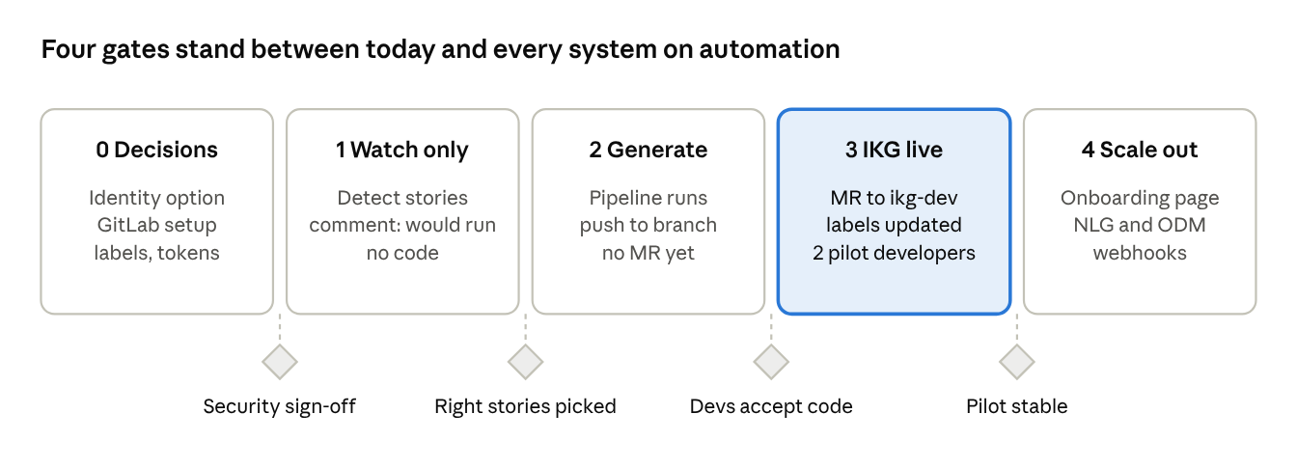
Rollout · 5 phases, 4 gates
Each phase starts only when the gate before it is passed. Watch-only mode proves the tool picks exactly the right stories before any code is pushed. Phase 3 (highlighted) is the first point where MRs reach ikg-dev. Dates depend on how quickly the phase 0 decisions are made.

10. Outstanding questions
For the manager
- ☐ Is a bot account acceptable as MR author if security refuses developer consent?
- ☐ Should a low-quality run still raise a Draft MR, or stop and only comment on the story?
- ☐ What happens with a story labelled both ikg and nlg: two branches in two repos, or blocked?
- ☐ Is there a daily cost limit for LLM usage, and who receives the cost report?
- ☐ Should the automation add reviewers to the MR automatically, and who?
For security
- ☐ Which identity option is approved: A consent, B bot, C stored token?
- ☐ Can refresh tokens (option A) be stored in the vault per GPN, and for how long?
- ☐ Is it acceptable to drop the current rule that a push needs a token typed by the user?
For the GitLab admin
- ☐ Is "story from git" GitLab issues (not Jira)?
- ☐ How is In progress recorded: scoped label, board column or Status field?
- ☐ Is there a GitLab edition limit on iterations, the Status field or OAuth applications?
- ☐ Do push rules check that the commit author matches the pusher?
- ☐ What API rate limits apply to a polling account?
For the IKG team
- ☐ Is the assignee always the developer who will own the code, and is there only one?
- ☐ Are story descriptions detailed enough today (tables, rules, acceptance criteria), or do they need a template?
- ☐ Should re-runs use only new story comments, or MR review comments too?
- ☐ Is ikg-master always the right base, or do some stories start from a release branch?

11. Risks and safeguards
Risk | Safeguard
Code pushed in a developer's name without their knowledge | Consent once per developer, or bot as author; comment on the story at start and end; MR assigned to the developer
Poor code reaches ikg-dev | Never auto-merge; Draft MR below the quality threshold; review findings in the MR
The automation triggers itself in a loop | Ignore label events made by its own account; re-run limit per story
Same story processed twice | State table plus a lock per story
Runaway LLM cost | Daily cap on runs and cost; 1–2 workers; per-run token report
Stale pack produces wrong code | Pack age check; ai_blocked if too old
A colleague pushed to the same branch | Existing safe-push logic: integrate on top, never overwrite
Tokens leak | Vault only; tokens passed per command and masked in logs and errors
GitLab down or rate-limited | Retry with back-off; the regular check catches up
Story too vague to code | Story agent's open questions posted as a comment; label ai_blocked
Need to stop everything quickly | Global and per-system on/off switch

12. Advanced features
Both are possible with GitLab's standard API, and both reuse the watcher and worker described above.

A. Fixing code from MR review comments
Yes. When a reviewer comments on an MR the automation raised, it can change the code, push to the same branch and reply in the comment thread. No new MR is needed: the open MR picks up the new commits automatically.
- Detect. The watcher also checks the automation's open MRs for new discussions (the MR discussions API, or the comment webhook later). Line comments come with the file and line they point at.
- Decide. Only act on a clear trigger, so ordinary chat between reviewers does not start a run. Suggested trigger: the reviewer starts a comment with /ai fix, or marks the MR as "changes requested".
- Fix. Collect every unresolved discussion, with its file, line and text. Pass them to the existing change step as one change request. The validator and reviewer agents check the result as usual.
- Push. New commits go on the same branch, with the safe-push logic if the developer has also pushed.
- Reply. In each thread, reply with what changed and the commit link. If the automation disagrees or can't make the change, it says why instead. Threads are left for the reviewer to resolve.
- Label. The story gets ai_review_fix_done, and the progress comment (B below) shows the round.
Safeguards:
- Ignore comments written by its own account, so it never answers itself.
- Limit rounds per MR (for example 3), then ask for a person.
- Never act on a merged or closed MR, or after the developer adds a no-ai label.
- Replies are posted under the same identity as the push (developer consent or bot), saying they were written by Agile Dev Assist.

B. Live progress on the story
Yes, with one design choice: the automation keeps one progress comment on the story and edits it as each agent finishes, rather than posting a new comment per step. A comment per step would send everyone watching the story a notification each time.
The progress comment holds:
- A checklist of the stages (story, knowledge, data, repo, planner, coder, validator, reviewer, push, MR), each ticked with its time as it finishes.
- The current step, for example "coder: 4 of 7 files written".
- On completion: files changed, validator and review results, confidence, tokens and cost, links to the branch and MR.
- On failure: the stage that failed and the reason, in plain words.
- A link to the full run as a chat in the Agile Dev Assist web app, for the detailed log.
How it behaves:
- Updates are grouped, at most one edit every 20–30 seconds, to stay within GitLab's rate limits.
- Re-runs and review-fix rounds start a new progress comment, so each run's history stays readable.
- The comment can be marked internal, so only project members see it.
- Developers see changes when they refresh the story. Newer GitLab versions refresh comments on the page automatically; the GitLab admin can confirm what our version does.
- No code, data rows or secrets are written to the comment, only stage names, counts, scores and links. Errors are masked the same way as in the web app.
The same progress comment is used on the MR during a review-fix round.

Extra questions these raise
- ☐ Which trigger should start a review fix: /ai fix, "changes requested", or any unresolved comment?
- ☐ Should the automation resolve threads itself after fixing, or always leave that to the reviewer?
- ☐ Should the progress comment be internal (members only) or visible to everyone who can see the story?
- ☐ When a manual pack upload and the Knowledge Pack job disagree, which wins?
- ☐ Who can edit settings and upload packs: one admin per system, or the whole team?
- ☐ Can the Greenplum DBA create the automation's schema and a writer login?

13. Built version: decisions and workflows
The first version is built as Story Autopilot (web app + notebook). Every rule below is a setting in config/autopilot_config.yaml, so a criterion or a new app needs no code change.

Pick-up rules
The watcher polls the story project every 2 minutes (poll_minutes) and reads the current iteration (or a pinned iteration id). A story enters the queue when all four hold:
Criterion | Setting | Default
Latest status is In progress | criteria.in_progress_label | status::In Progress, story open
Ready for the agent | criteria.ready_label | ready_for_agent, added in the scrum meeting
At least one app label | onboarding table | IKG, NLG, ODM; IKG + ODM loads both packs, two branches, two MRs
An assignee | criteria.require_assignee | exactly one (multiple_assignees: block)
A story is not picked up again when it has agent_code_done, agent_re_code_done or ai_failed, or when it came back to In progress from status::QA, status::UAT or closed. In both cases only re_work_for_agent releases it. The previous status is read from the story's label and state history, so a move from closed shows as "closed".
A story that is ready but has no app label or no assignee gets ai_blocked and one comment naming what is missing; the comment is not repeated on every poll.
The worker takes one job at a time. Waiting stories stay in the queue, and the control center can reorder or remove them.

Story label lifecycle
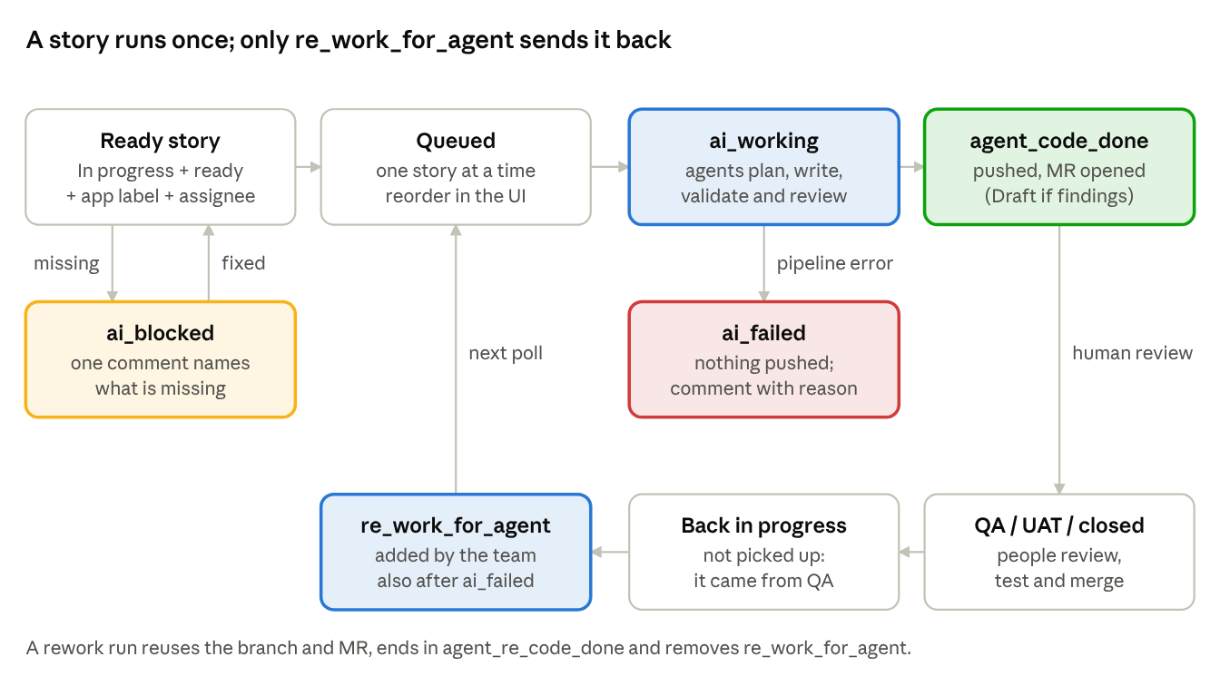
story labels · first run, blocked, failed, rework
A done story is never picked up again by itself: after QA, UAT or a close, only the re_work_for_agent label sends it back to the agent.

MR review fix (/ai-fix)
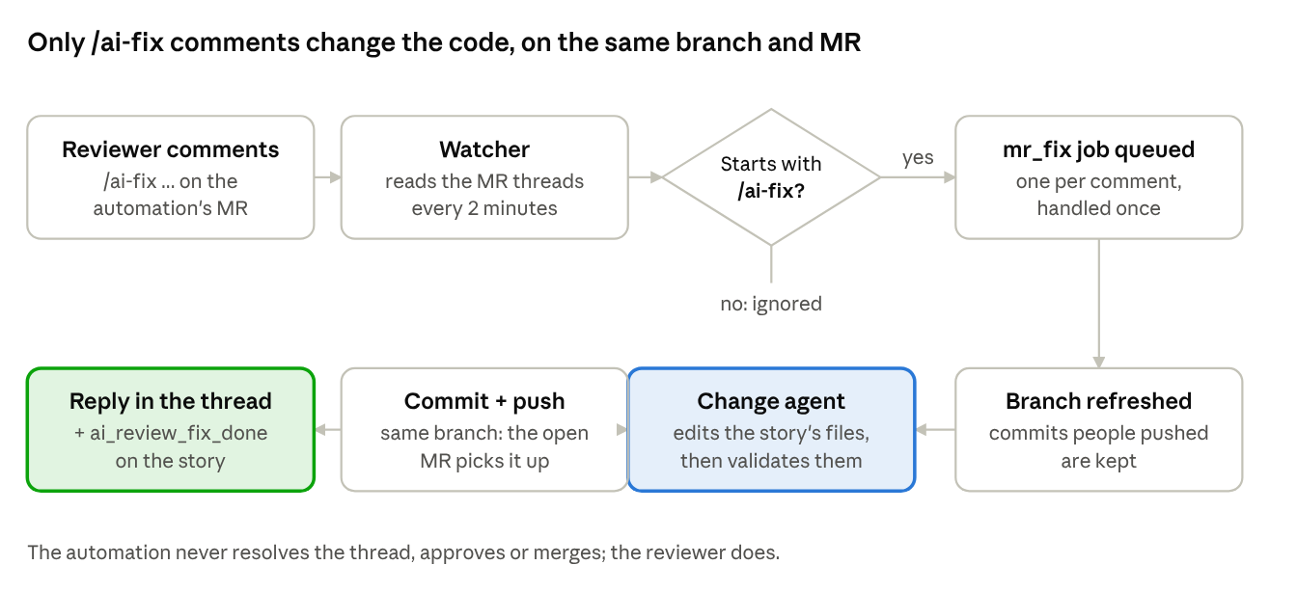
MR review fix · /ai-fix comment to reply
Only comments that start with /ai-fix are acted on; each is handled once, in queue order with the stories, and the reply in its thread names the changed files and the commit.

Branch, commit and MR identity
Commits carry the developer's name; the MR is created by the token owner and assigned to the developer. GitLab records the creator of an MR as whoever's token made the call, so the shared token cannot create it as the developer.
Item | Convention | Who it shows
Branch | <story id>-<app>-<feature>-ai, from the app's base branch (ikg-master) | reused for every later run of the story
Commit | <story id>-<app>-ai | author = assignee ("shah pratik 49010206" → Pratik Shah, GPN 49010206, GitLab e-mail); committer = token owner
Merge request | into the app's target branch (ikg-dev), created once then updated | created by the token owner, assigned to the assignee
To have the MR itself created by the developer, set git.token_mode: per_user (each developer's token from the vault, after a one-time Authorize) or use an admin impersonation token. The automation never approves or merges.
Outcome | Push | MR | Story
Review passed, confidence ≥ 70 | yes | ready | agent_code_done + comment with links
Open critical / high finding, or confidence < 70 | yes | Draft, findings in the description | comment asks the assignee to look
Pipeline error | no | none | ai_failed + comment with the reason

Switches, limits and onboarding
Setting | Effect
autopilot.enabled | global on/off (also a switch in the control center)
enabled per app (onboarding page) | an app's stories are ignored when off
dry_run | decide and log, write nothing to GitLab
git.push, git.merge_request, mr_fix.enabled | turn the push, the MR or /ai-fix off
limits.usd_per_day | the queue pauses for the day when reached
limits.usd_per_story | the story is blocked with a comment when reached
limits.max_minutes_per_story | time budget of one agent run
Apps are rows of sandbox_prj_smart_insights.story_autopilot_apps on greenplum-rdsp.zur.swissbank.com:5432/gprdsp (user ds_rdsp_dev), written by the onboarding page: story label, pack, repository, base and target branch, optional branch and commit templates. Test connection checks the pack, both branches, the label and the table. The password comes from the vault (Azure Key Vault reference or HashiCorp vault), never from a file. Missing labels are created once on the story project.
Two deliverables:
- Notebook (story_autopilot_notebook.zip): asks for the Azure key, the GitLab token and the Greenplum password, then shows Start / Stop / Poll buttons and the buttons that open the control center and the onboarding page.
- Web app (story_autopilot_webapp.zip): a standalone service that keeps the watcher, the worker and the agents running and serves the control center (/) and the onboarding page (/onboarding/) behind SSO.
The control center shows iteration folders ("Nov 4 - 17, 2026") with one sub-entry per story, search, the story being processed with its live log, the queue (drag to reorder), and per story the context pack, plan, files, review, log, tokens and outputs.

